Occupational health and safety when working from home

During a work from home scenario, an employee’s home is considered their workplace. Therefore, the employer has an obligation to provide and maintain a safe workplace as far as reasonably practicable, and employees have an obligation to take all reasonable steps to ensure their own health and safety. As a starting point, prior to commencing work from home, managers and employees should have a discussion regarding the circumstances that will apply in their individual situation to ensure the workplace is safe.

Whilst we are all obliged to take reasonable steps to provide and maintain a safe workplace, should an employee injure themselves whilst at work they need to inform their manager or HR and complete an Incident/Accident/Near-Miss Report Form. This is available at Incident/Accident/Near-Miss Report Form on the CAM website.

In the context of a complete office closure, it may be challenging for some employees to fully replicate their usual office-based workstation layouts. Employees working from home must ensure:

- you have a chair that is comfortable to sit on while working;
- there is sufficient light and space for you to work;
- you clear or otherwise control any tripping hazards such as cords on the floor; and
- heating/ cooling/ ventilation are adequate for you to work.

As with any type of office work, the prolonged maintenance of a static posture presents a risk of musculoskeletal injury in any environment, and the home environment presents unique challenges given its multipurpose set-up. Therefore, employees are encouraged to frequently alternate both posture and task to maximise comfort.

An HR telephone number (03 9926 2424) and email (hradmin@cam.org.au) will be monitored throughout periods of significant disruption to assist employees with any queries.

To assist with meeting employer obligations to provide and maintain a safe workplace as far as reasonably practicable, and for employees to take all reasonable steps to ensure their own health and safety, we request all employees to complete the following Workstation Ergonomics Self-Assessment.

This self-assessment tool can be used in any workplace regardless of whether it’s in the office or at home.

Workstation Ergonomics Self-Assessment

This Workstation Ergonomics Self-Assessment has been provided to help meet employer obligations to provide and maintain a safe workplace and for employees to take all reasonable steps to ensure their own health and safety.

It is best if undertaken by two people. This enables the person to sit at their workstation while a second person observes and assists them achieve the recommended posture.

Item | The Office Chair | Yes | No | N/A | Suggested Actions
1. | Can the height, seat and back of the chair be adjusted to achieve the posture outlined below? |  |  |  | - Obtain a fully adjustable chair
2. | Are your feet fully supported by the floor when you are seated? |  |  |  | - Lower the chair  - Use a footrest
3. | Does your chair provide support for your lower back? |  |  |  | - Adjust chair back  - Obtain proper chair  - Obtain lumbar roll
4. | When your back is supported, you able to sit without feeling pressure from the chair seat on the back of your knees? |  |  |  | - Adjust seat pan  - Add a back support
5. | Do your armrests allow you to get close to your workstation? |  |  |  | - Adjust armrests  - Remove armrests

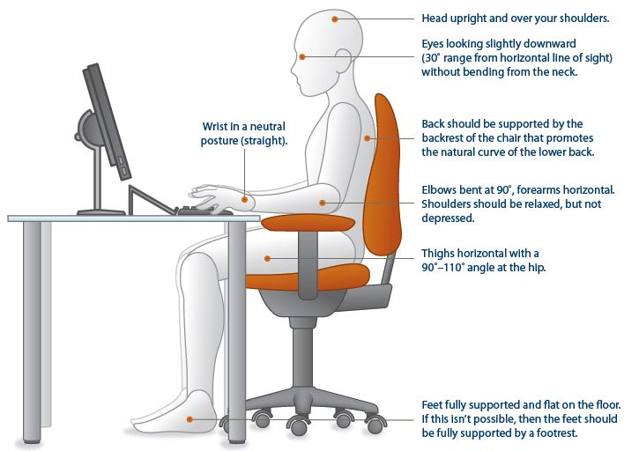

Item | Keyboard and Mouse | Yes | No | N/A | Suggested Actions
6 | Are your keyboard, mouse and work surface at your elbow height? |  |  |  | - Raise / lower workstation  - Raise or lower keyboard  - Raise or lower chair
7 | Are frequently used items within easy reach? |  |  |  | - Rearrange workstation
8 | Is the keyboard close to the front edge of the desk allowing space for the wrist to rest on the desk surface? |  |  |  | - Move keyboard to correct position
9 | When using your keyboard and mouse, are your wrists straight and your upper arms relaxed? The keyboard should be flat and not propped up on keyboard legs as an angled keyboard may place the wrist in an awkward posture when keying. |  |  |  | - Re-check chair, raise or lower as needed  - Check posture  - Check keyboard and mouse height
10 | Is your mouse at the same level and as close as possible to your keyboard? |  |  |  | - Move mouse closer to keyboard  - Obtain larger keyboard tray if necessary
11 | Is the mouse comfortable to use? |  |  |  | - Rest your dominant hand by using the mouse with your non-dominant hand for brief periods (mouse buttons can be changed within the computer control panel)  - Investigate alternate mouse options.

Item | WorkSurface | Yes | No | N/A | Suggested Actions
12 | Is your monitor positioned directly in front of you? |  |  |  | - Reposition monitor
13 | Is your monitor positioned at least an arm’s length away?  Note: the monitor’s location is dependent on the size of the monitor, the font, screen resolution and the individual user e.g. vision/use of bifocal spectacles etc. |  |  |  | - Reposition monitor  - Seek an alternative monitor if necessary e.g. flat screen that uses less space
14 | Is your monitor height slightly below eye level? |  |  |  | - Add or remove monitor stand  - Adjust monitor height
15 | Is your monitor and work surface free from glare? |  |  |  | - Windows at side of monitor  - Adjust overhead lighting  - Cover windows  - Obtain antiglare screen
16 | Do you have appropriate light for reading or writing documents? |  |  |  | - Obtain desk lamp  - Place on left if right-handed – place on right if left handed
17 | Are frequently used items located within the usual work area and items which are only used occasionally in the occasional work area? |  |  |  | - Rearrange worsktation

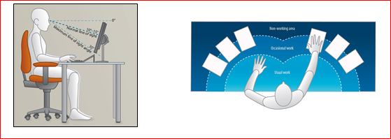

Item | Breaks | Yes | No | N/A | Suggested Actions
18 | Do you take postural breaks every 30 minutes? E.g. standing, walking to printer / fax etc.? |  |  |  | - Set reminders to take breaks
19 | Do you take regular eye breaks from looking at your monitor? |  |  |  | - Refocus on picture on wall every 30 minutes

Item | Accessories | Yes | No | N/A | Suggested Actions
20 | Is there a sloped desk surface or angle board for reading and writing tasks if required? |  |  |  | - Obtain an angle board
21 | Is there a document holder either beside the screen or between the screen and keyboard if required? |  |  |  | - Obtain document holder
22 | Are you using a headset or speakerphone if you are writing or keying while talking on the phone? |  |  |  | - Obtain a headset if using the phone and keyboard
Item | Laptop | Yes | No | N/A | Suggested Actions
23 | In the event of using a laptop computer for prolonged periods of time use of;  - A full sized external keyboard and mouse;  - Docking station with full sized monitor or a laptop stand |  |  |  | - Obtain appropriate laptop accessories
Item | “Hot Desking” (when applicable) | Yes | No | N/A | Suggested Actions
24 | Provided time, support and supervision to make above adjustments.

Following completion of this checklist, please discuss any concerns or requirements with your supervisor.

All completed assessments should be submitted via email to your supervisor and to hradmin@cam.org.au.

Person completing assessment

Name |  | Position
Signature |  | Date

Supervisor

Name |  | Position
Signature |  | Date
Comments

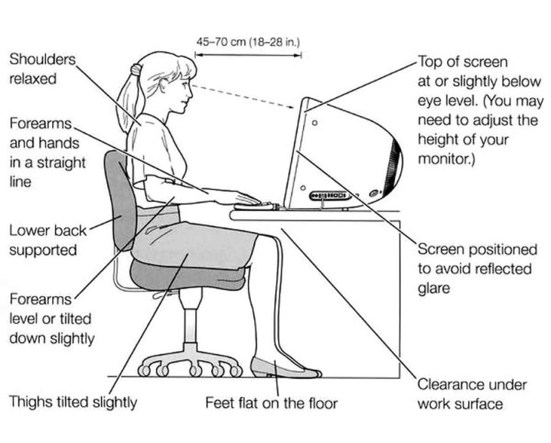

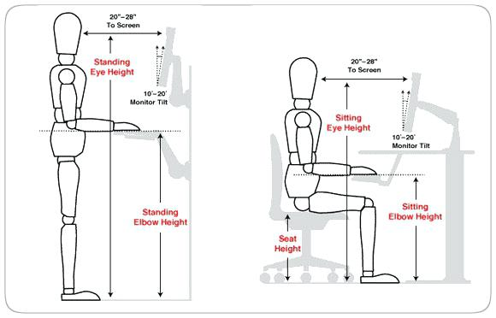
45 -70cm
to screen
45 -70cm
to screen

